A000-CAN-Umiak-Rawhide and Wood-19th c

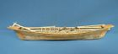

Case No.: 12

**Accession No.**

**Formal Label:**

**Display Description:**

The structure of this Umiak or Women’s kayak follows the ethnographic information preserved in Edward Curtis’ photographs.

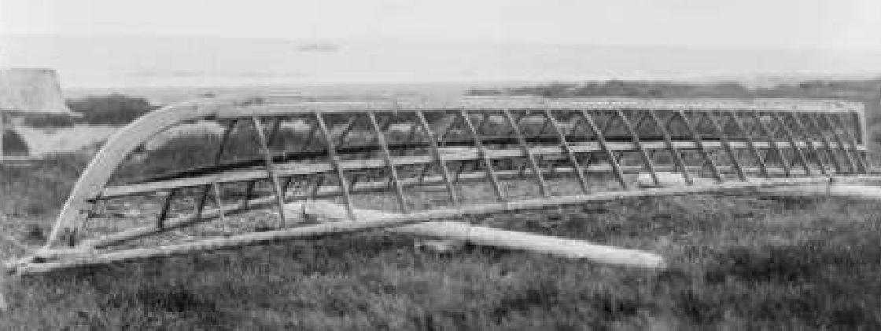

Creator(s): Curtis, Edward S., 1868-1952, photographer   
Date Created/Published: c1929.   
Notes:   
Edward S. Curtis Collection.  
Published in: The North American Indian / Edward S. Curtis. [Seattle, Wash.] : Edward S. Curtis, 1907-30, v. 2, p. 182.

**LC Classification:**

**Date or Time Horizon:**

**Geographical Area:**

**Map:**

**GPS coordinates:**

**Cultural Affiliation:**

**Media:**

**Dimensions:**

**Weight:**

**Condition:**

**Provenance:**

**Discussion:**

**References:**

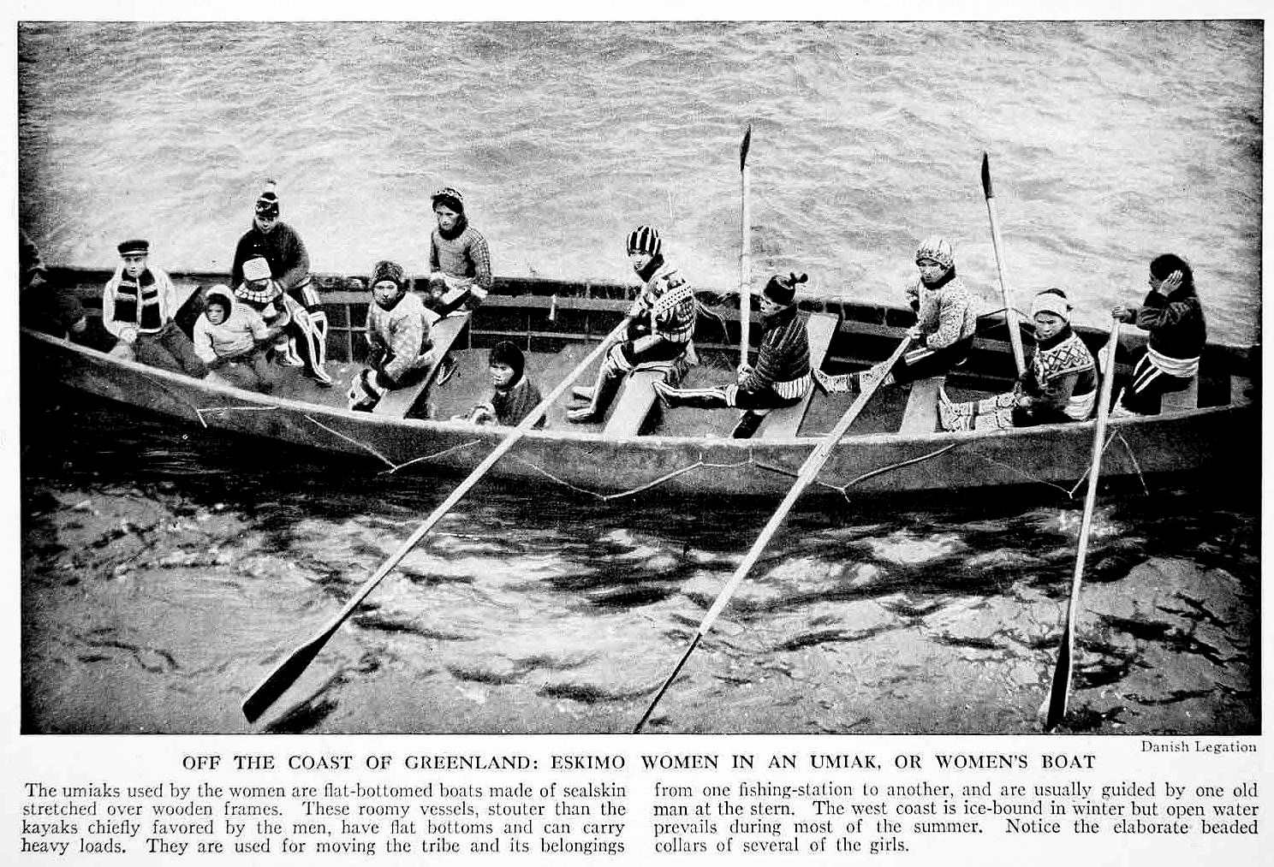

# 1938 Greenland Native Eskimo Women in Traditional Dress in an Umiak Boat

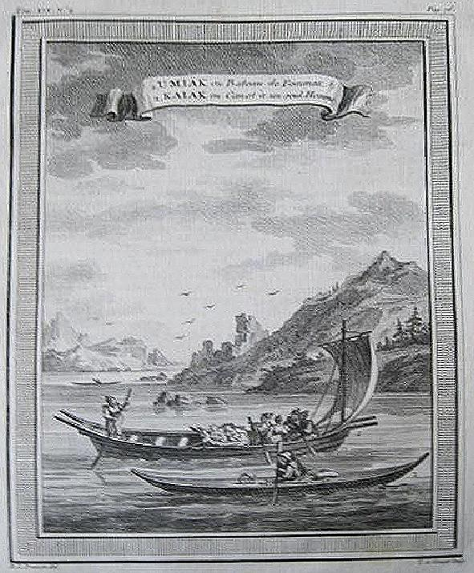

This is a print from a collection of prints from Umiak (Bateau de Femme) Kaiak ou Canot a un seul Homme. c1749.